Identification of Communist Block Oil Bottles
Written by Richard Barnes

During six years service with the French Foreign Legion a good proportion of that time spent in Africa, I got a lot of experience with AK47’s/AKM’s. This experience was complimented in the early 1990’s with more AK time while serving in the ‘Explosive Ordnance Disposal’ squadron of the British Army reserve. An important part of the EOD work has been ‘making safe’ terrorist weapons that are located during searches etc. therefore EOD personnel need knowledge of all potential terrorist weapons…..

In the United Kingdom we have very strict, some would say draconian, gun laws and since the late 1980’s it has been very difficult to obtain a weapons permit to own a semi Automatic weapon, and from the mid 1990’s it became impossible as everything but bolt action long rifles where banned. However looking at gun crime statistics, we now have more gun crime in the UK, than ever before. Reports often state criminals are using full auto weapons, brought back from the former Yugoslavia etc. in shoot outs! Figure that out! Only the criminals (and police) have guns in the UK now!

But I stray from the point of this article, or do I? It is about identifying ‘Communist Block Oil Bottles’, if I could collect and use AK’s, I probably would not have bothered spending the time researching this, as I would have had more important things to do ha! Ha!

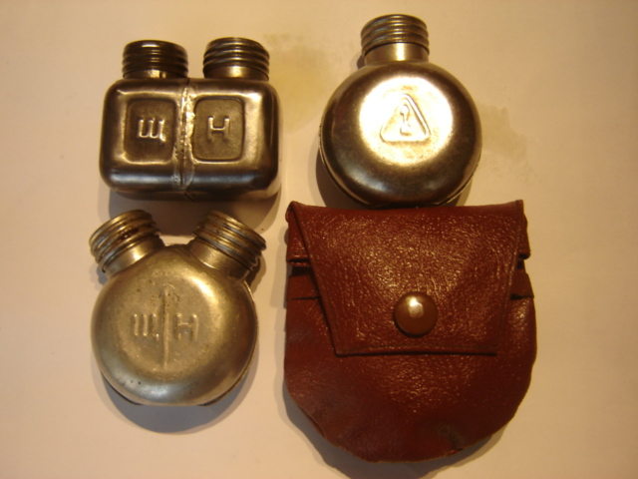

So where do we begin, Russian I guess? To the left is a picture of three types of Russian bottles I have come across. The early rectangular bottles issued with the AK47, the later double spout ‘round’ AKM version with its pouch beside it. These future the letters ‘W H’, which I am told mean the following: The ‘W’ is in fact the Cyrillic ‘ShCh’ & the world transliterates to ‘Shchelo’ which means lye or alkaline solution / Solvent. The ‘H’ is the Cyrillic ‘N’ and transliterates to ‘Neft’ or Oil. The round single spout bottle also in the picture which features the Izhvesk ‘Arrow in Triangle’ symbol, was originally issued with the SKS I was told. This particular bottle, with many others, came from the surplus Bosnian Government stocks.

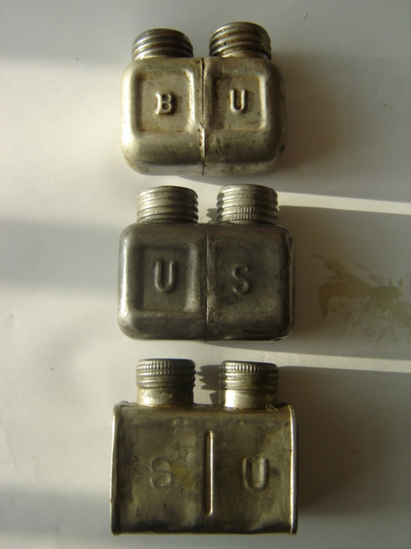
Next let us move onto the Romanian Bottles, picture to the right. The explanation for these I got from a former Romanian soldier via a contact in Hungary. U: Ulei (oil), S: Solvent (Solvent), B: Bazã (Alkali), hence the combinations of ‘S U’, ‘U S’ & ‘B U’.

Simple enough, but if you are thinking why are there two variations of letters for one country, let us look at Hungary, my contact Zoli, in Hungary, helped me out with decoding these.
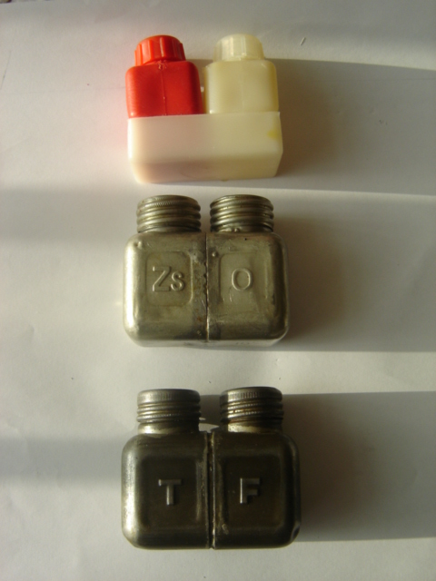
To the left we have the latest version of the Plastic bottle in red & white colours, ‘Zs O’ & one that threw me for a while, until I met Zoli on the internet, is ‘T F’.

Zs: zsír (oil), O: oldószer (solvent) / T: tisztítószer (cleaner/lye), F: fegyverolaj (oil).

That would have been three versions, if it was not for something that Zoli threw in to confuse matters; he sent me the picture below with the following explanation:

F: Fegyverolaj (oil), L: Lúg (lye).
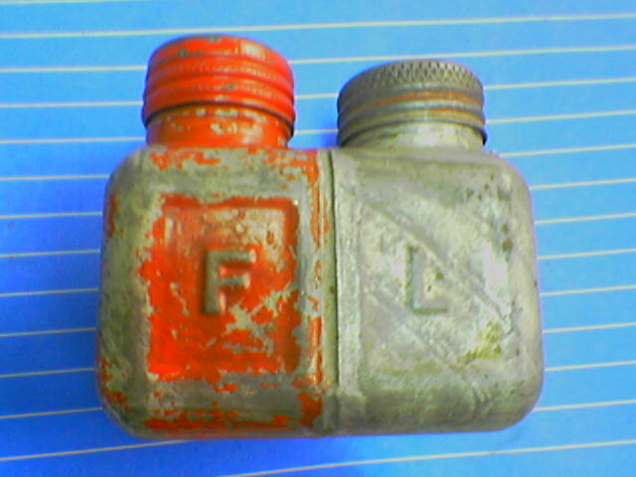

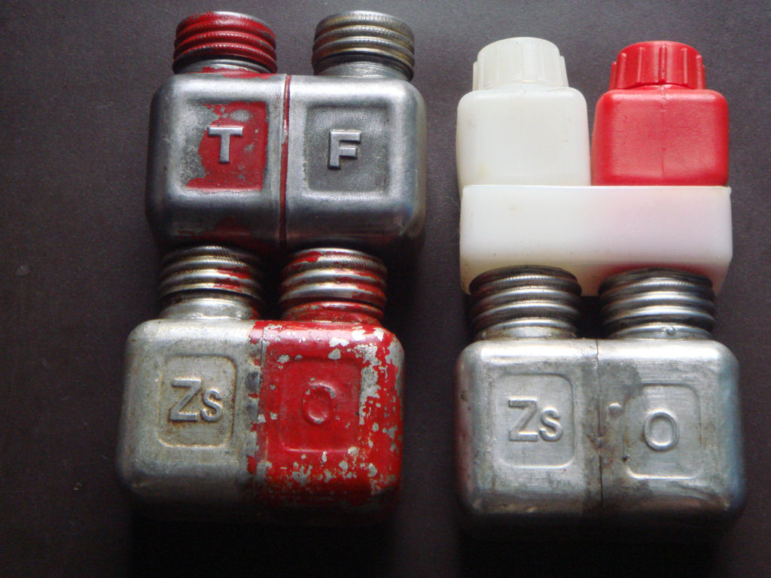
Enough to confuse anyone, three different set of letters from one country!

Incidentally, the ‘Zs O’ bottle is the only one I have come across that has the letters stamped on both sides of the bottle. Another fellow collector, Paul from the UK, sent me the picture to the right, which shows the Plastic red/ white bottle and a ‘Zs O’ and ‘T F’ painted red, as is the ‘F L’ in the other picture. So initially I thought this must have been the end users, the Hungarian Armed forces, method of simplifying things. If so, the red colour must mean the same thing…… but with the explanations given above this is not the case.

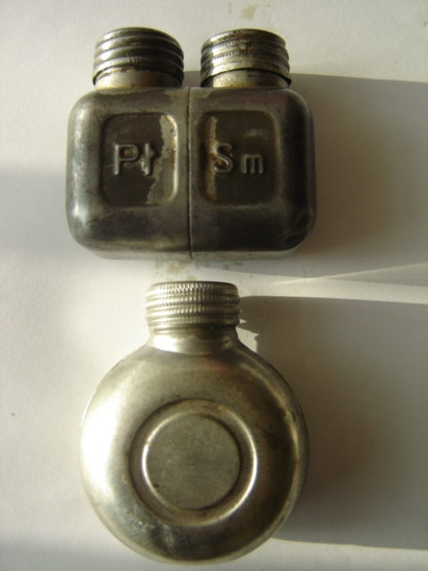
I have come across two Polish bottles, with an explanation for the letters on the rectangular bottle from a former Polish soldier who later served in the French Foreign legion:

Pł: PłYN (liquid) Sm: Smar (grease)

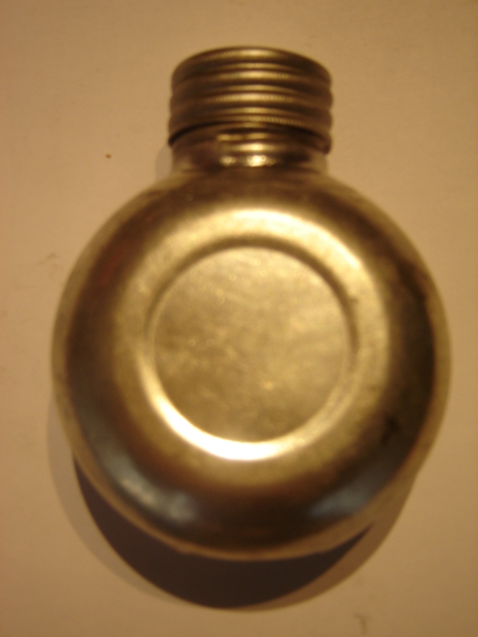
The single spout round bottle has no letters on it.

The Bulgarians also produced a single spout metal oil bottle, the one pictured on the right is an example of one of these, I am informed.

I enquired with a colleague, a Bulgarian who deals/works in arms business, if Bulgaria ever produced either a rectangular bottle or double spout round one, with different letters on them, keeping mind that both Russia and Bulgaria use the same Cyrillic alphabet with only slight differences. He had told me he had thousands of oil bottles, both Russian and Bulgarian, so I asked him “What is the difference between Russian and Bulgarian oil bottles, different letters?” He replied “They look the same; we pulled them out of different crates, some with Bulgarian, some with Soviet AK's”. He also told me “the letters mean alkaline & oil”.

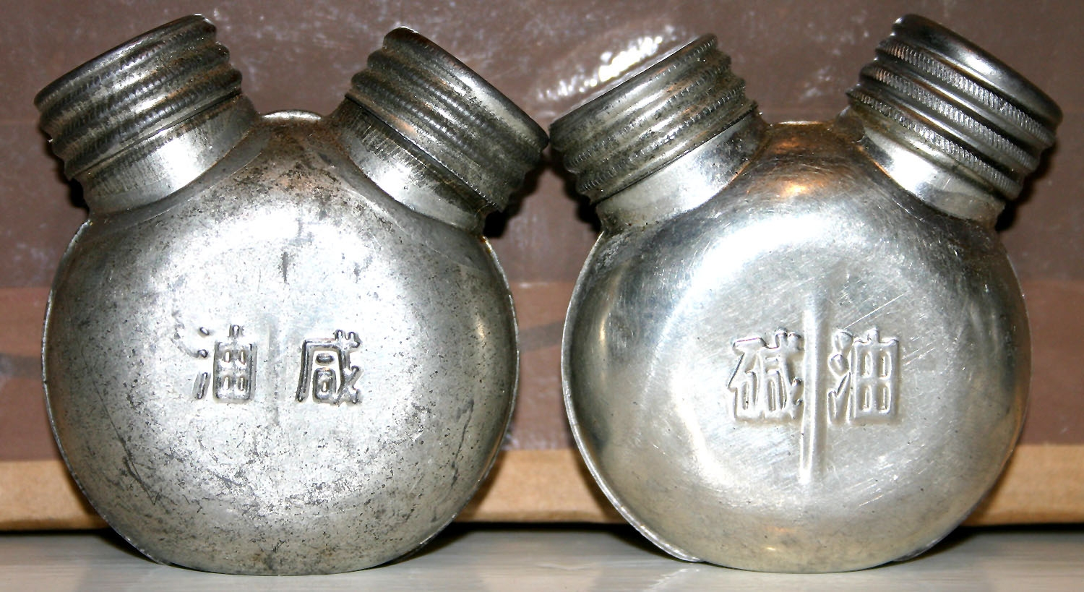

What else do we have, two Chi Com double spout bottles, for which no explanation of letters is required to identify the origin?

We also have two different shaped bottles with no letters, one green plastic and one metal. Although both these came back from Iraq, I am told they are originally Chinese?

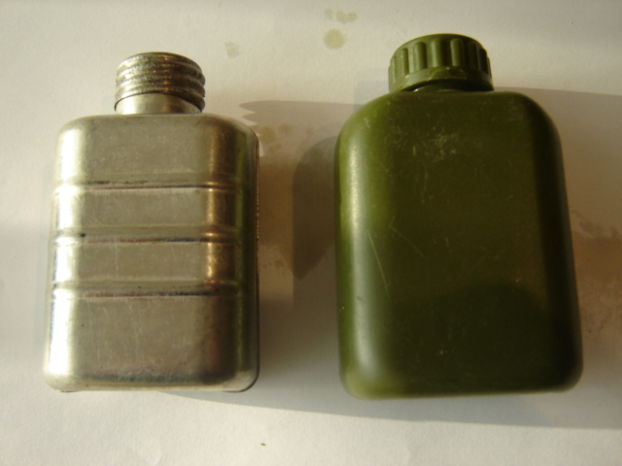

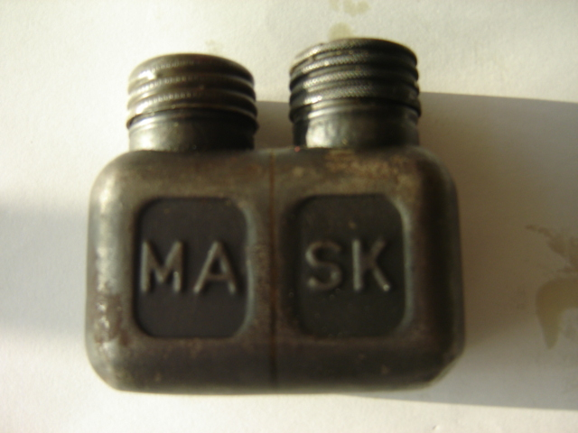
Another well used rectangular bottle I found has the letters ‘MA SK’; this one I have not positively identified yet, having followed many leads and contacts in Finland, Poland, Hungary etc. etc. From the internet and clues given what the letters mean on the other bottles, I think it may be Czechoslovakian. Reason, the MA may mean either ‘mastnota or mazadlo. The internet informed me was Czech for grease.

Anyone got any suggestions for the SK?

Two more modern oil bottles I have come across, made of black plastic are the bottles made for the AK74 rifles, here we have one from Romania (below left) & Bulgaria ( below right).
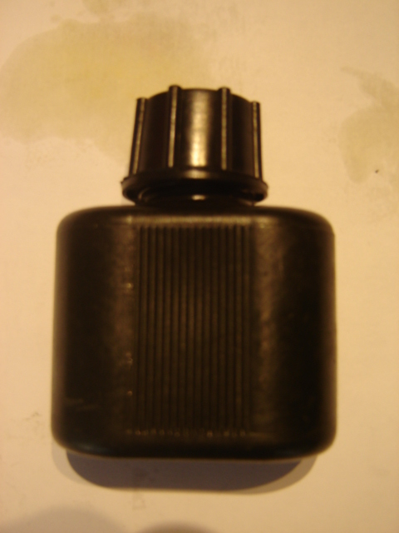
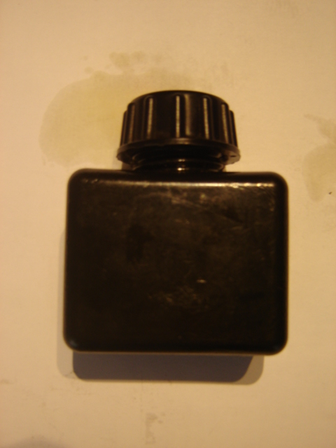

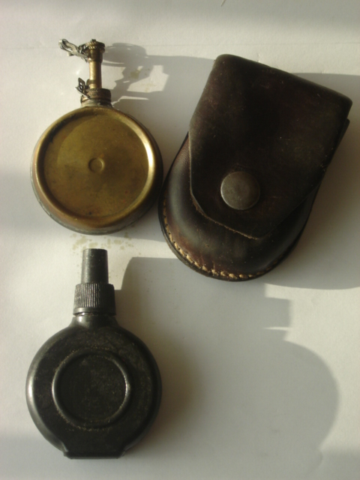
Yugoslavia had their own ‘banjo’ shaped oil bottle, which I am informed was copied from the oil bottle used by the Germans for their MG42’s in World war two. Considering the Yugoslavians continued to use the design of the MG 42 in the form of their M53, even down to retaining the 7.92mm calibre ammunition, this is believable. Two variants exist to my knowledge, one in brass, which was issued with the leather pouch for the Yugoslavian SKS rifle and the more modern black plastic oil bottle issued with the M70’s etc.

Mystery Bottle: Another bottle I have come across, which also has the Cyrillic letter ‘W H’, on it, is pictured below. It came from a contact in Hungary with some Hungarian AK pouches.

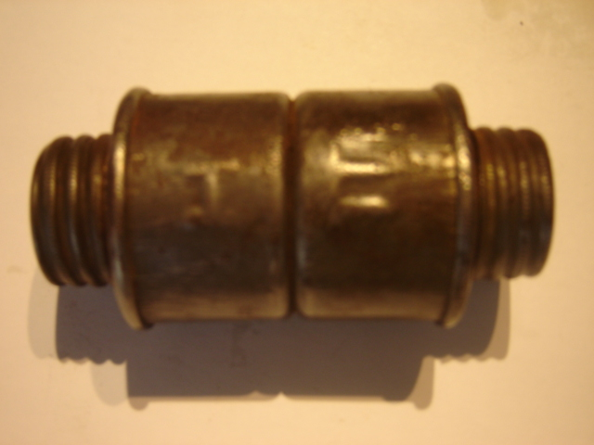
Interesting enough, I have come across the picture below on eBay, which is described as a ‘captured German Mauser oil bottle, captured by the Russians’. Looks very similar to ‘one half’ of the other bottle!
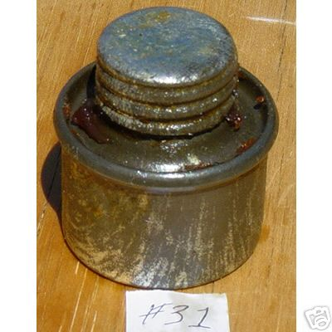

Some other ‘Mystery’ single spout bottles I have come across are pictured below, anyone able to identify where these may come from?

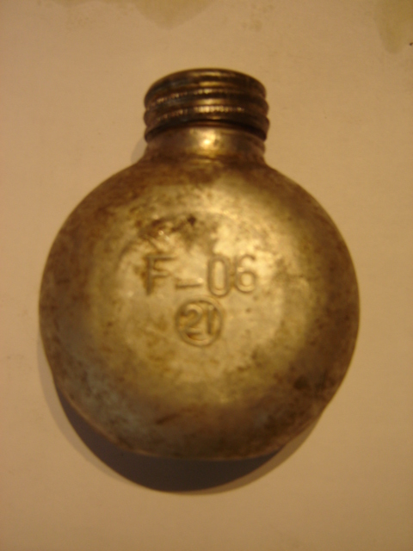
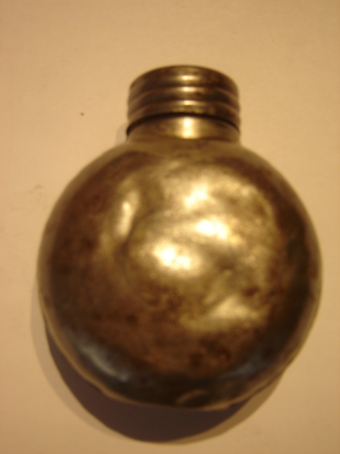
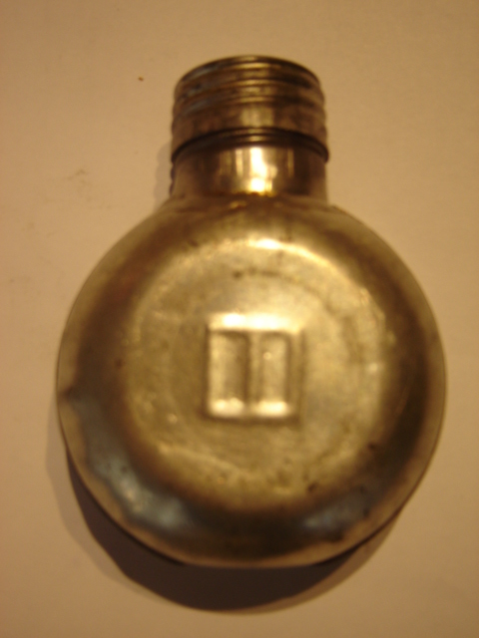
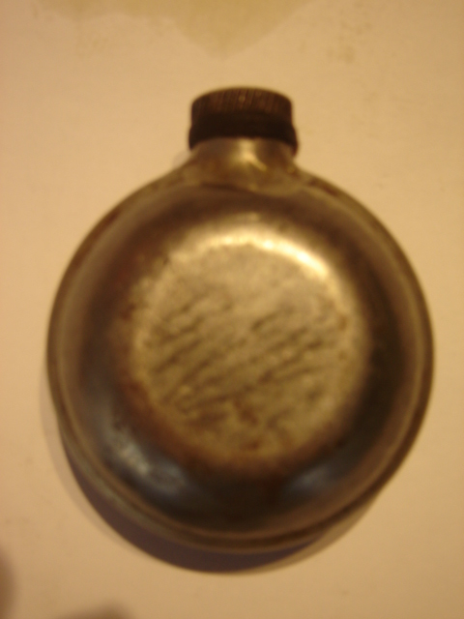

So there you have it and if you think what a hell of a way to pass some time away, think about our ‘draconian’ gun laws in the UK, and make sure you don’t end up down the same road. This article covers the ‘Slippery Slope’ of gun control that was imposed upon the UK, interesting reading and a warning for some:

http://www.davekopel.com/2A/LawRev/SlipperySlope.htm

